12). Create a Virtual Machine with 1 CPU, 2GB RAM and 15GB storage disk using a Type 2 Virtualization Software.

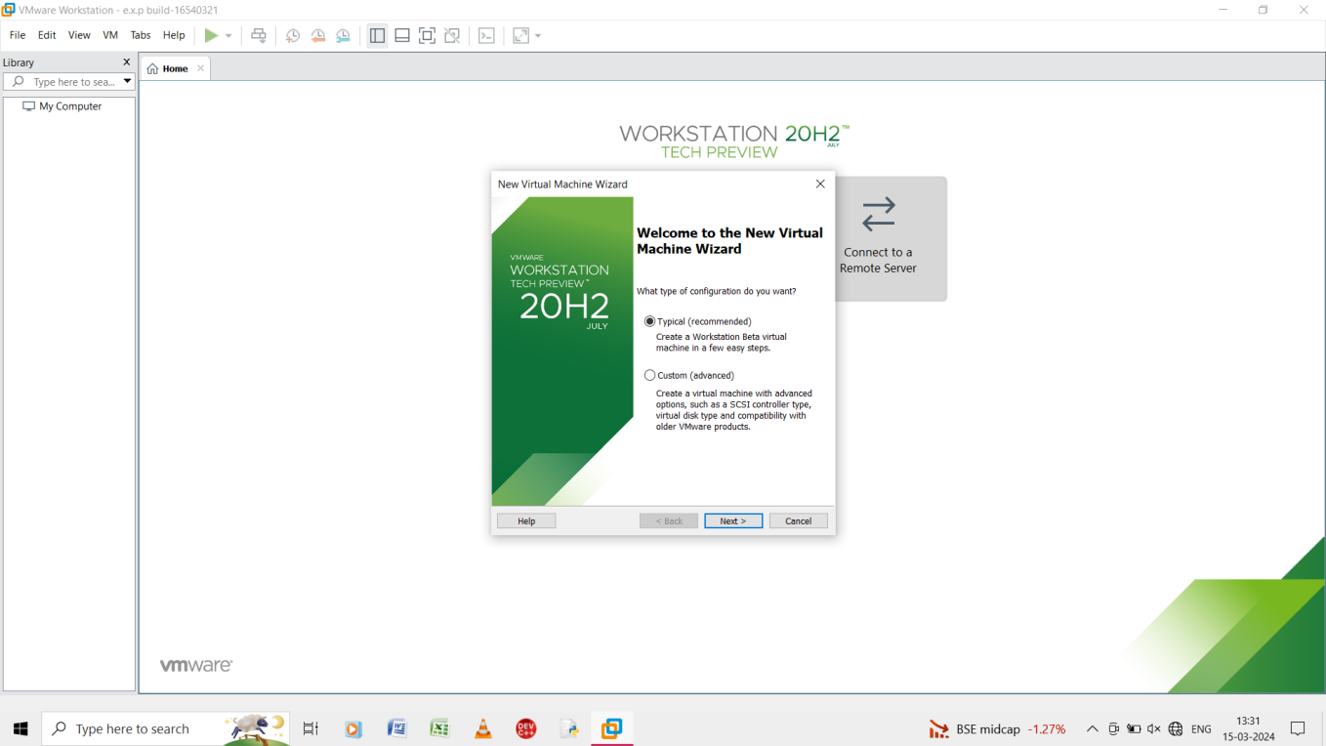

Step 1: to go file and create a new virtual machine and select typical.

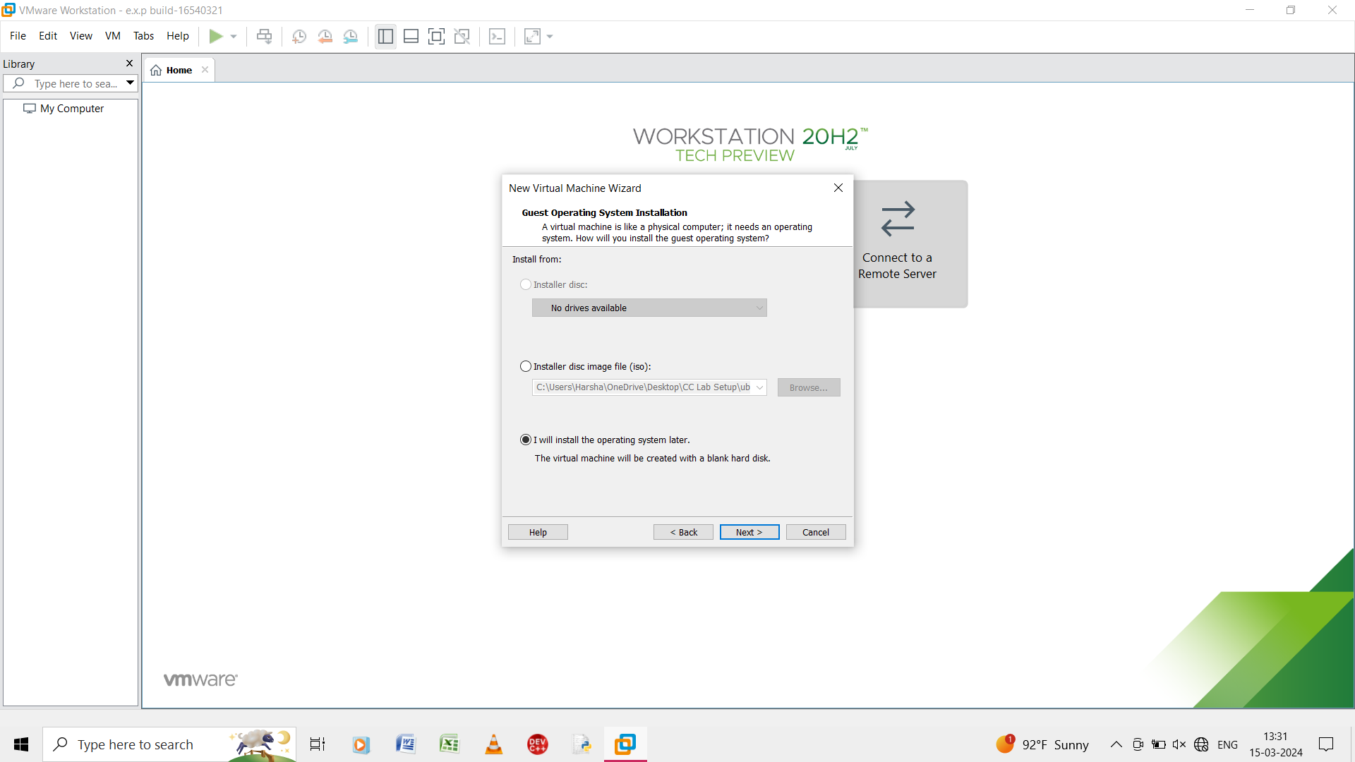

Step 2: in the guest operating system select the I will install the operating system later.

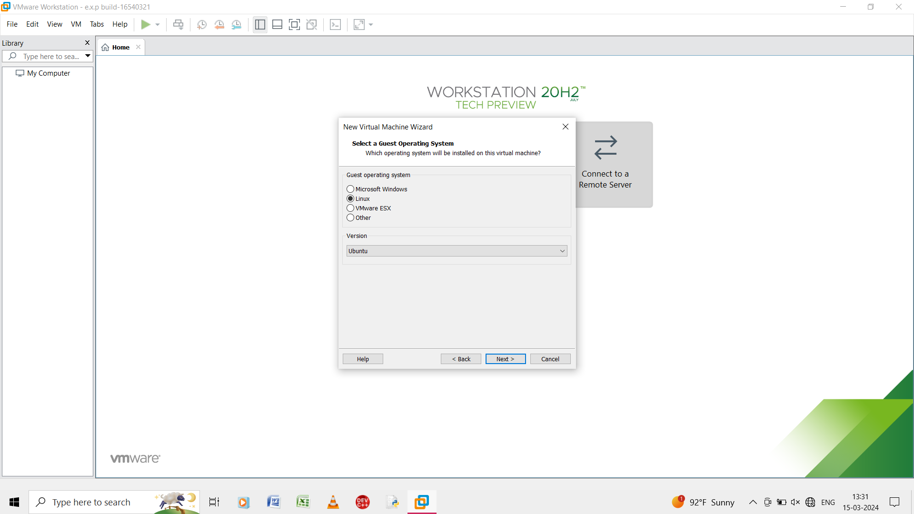

Step 3: select the guest operating system as linux.

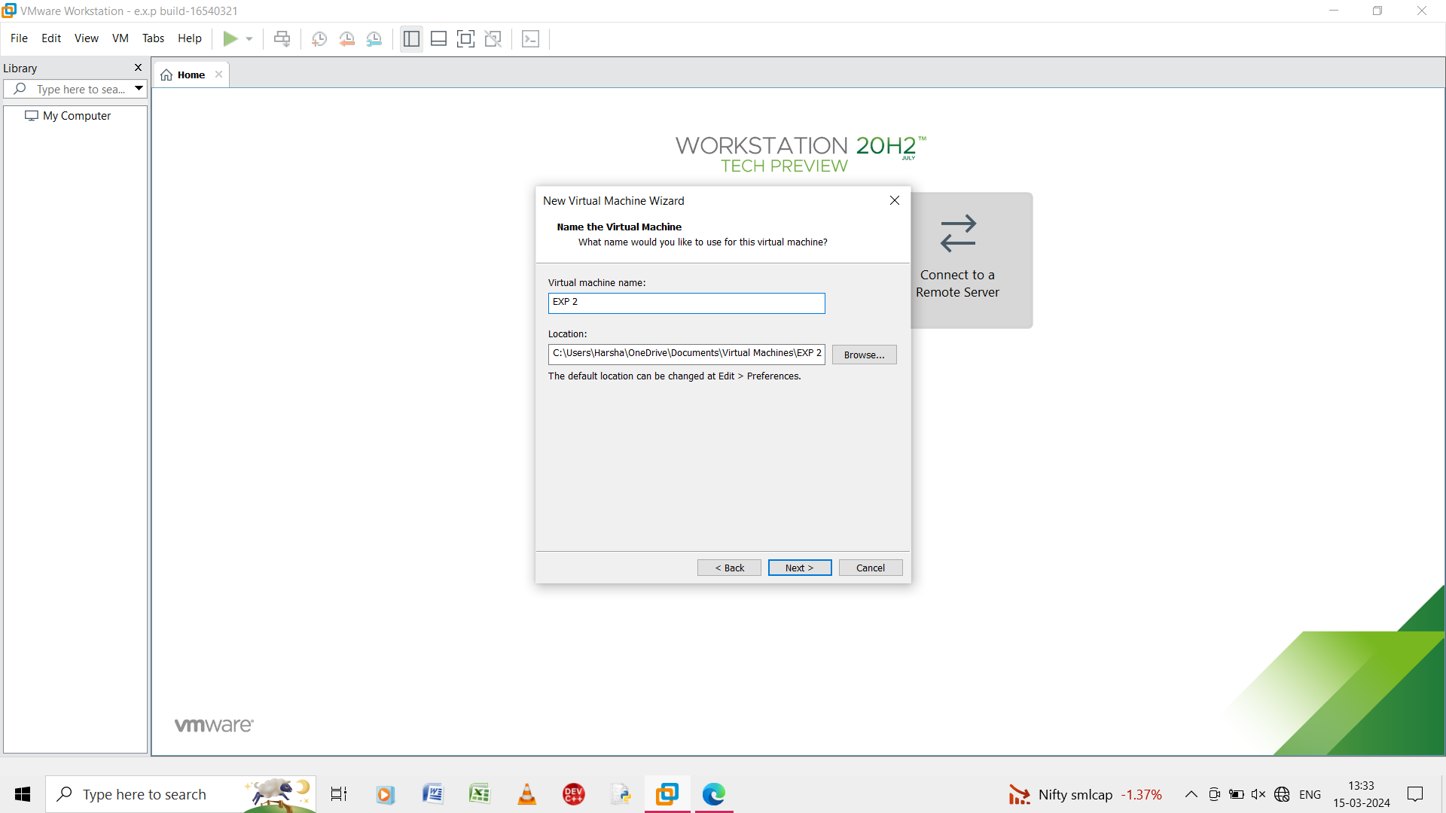

Step 4: give the name of the virtual machine as exp 2.

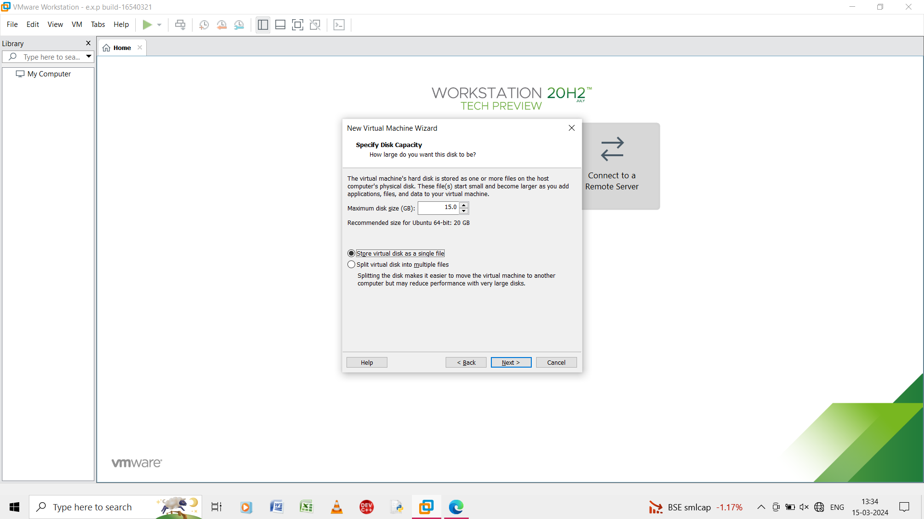

Step 5: in the specify disk capacity give maximum disk size and store the virtual disk in a single file.

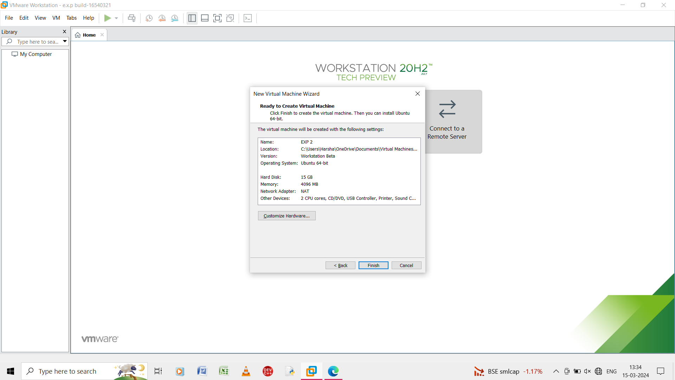

Step 6: in this step it is ready to create the vitual machine and it shows the summary of the virtual machine of the input.

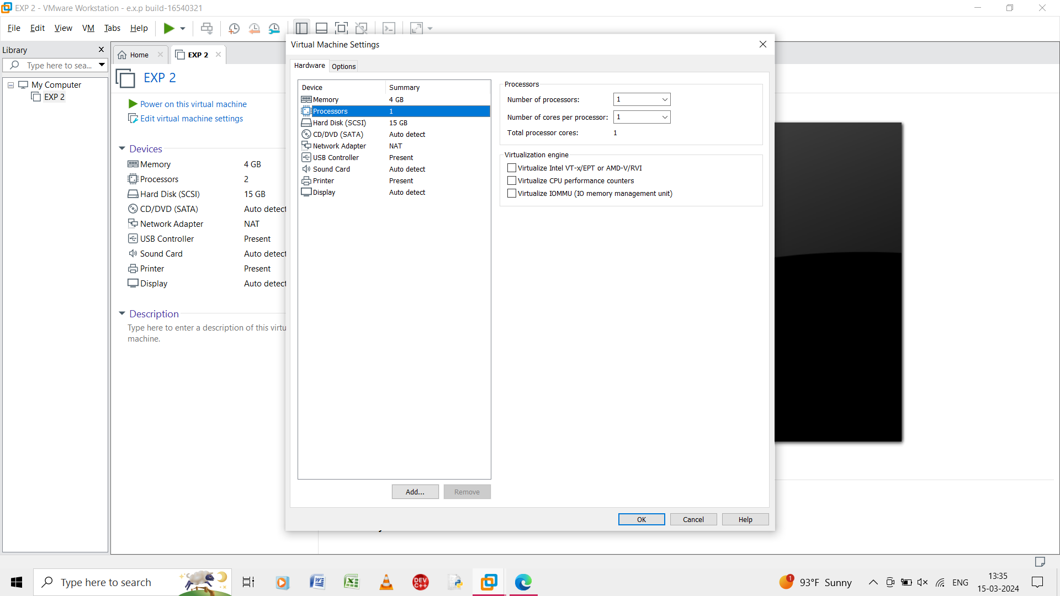

Step 7: give the details as per question and change the number of processors.

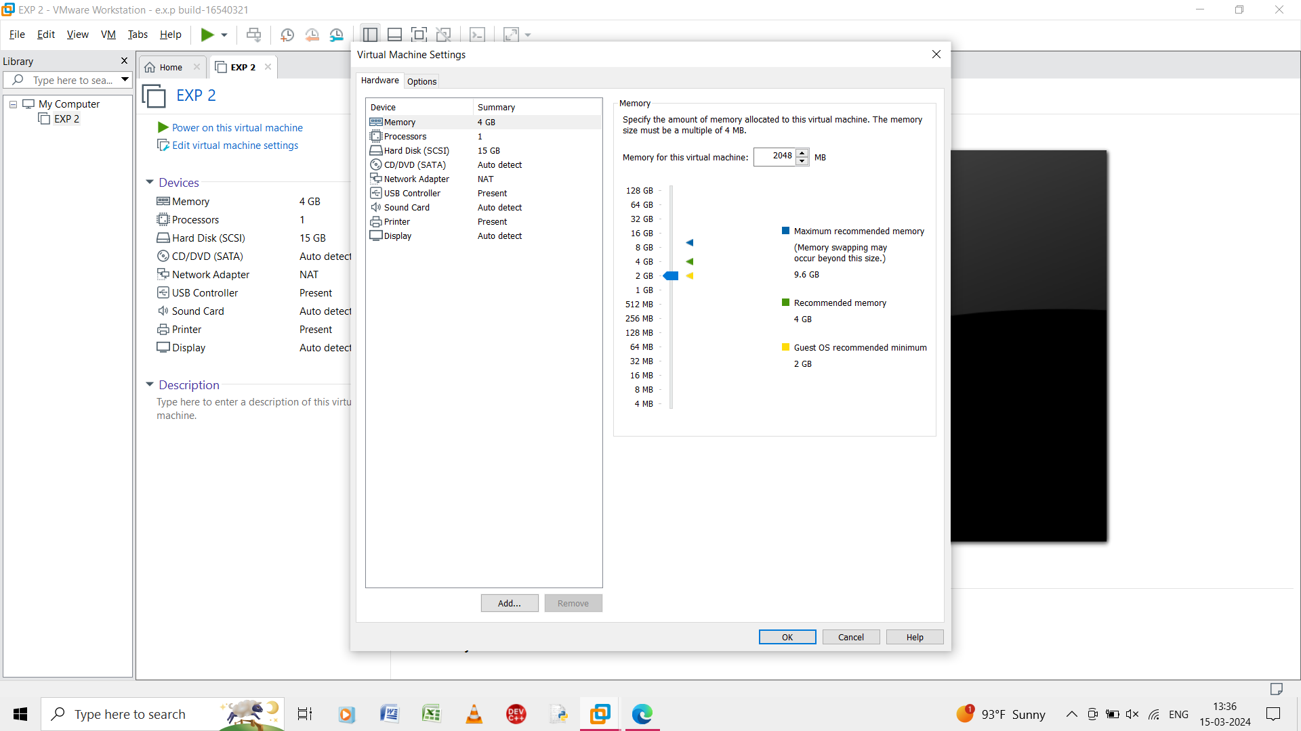

Step 8: give the memory size as 2048 mb as per question and submit.

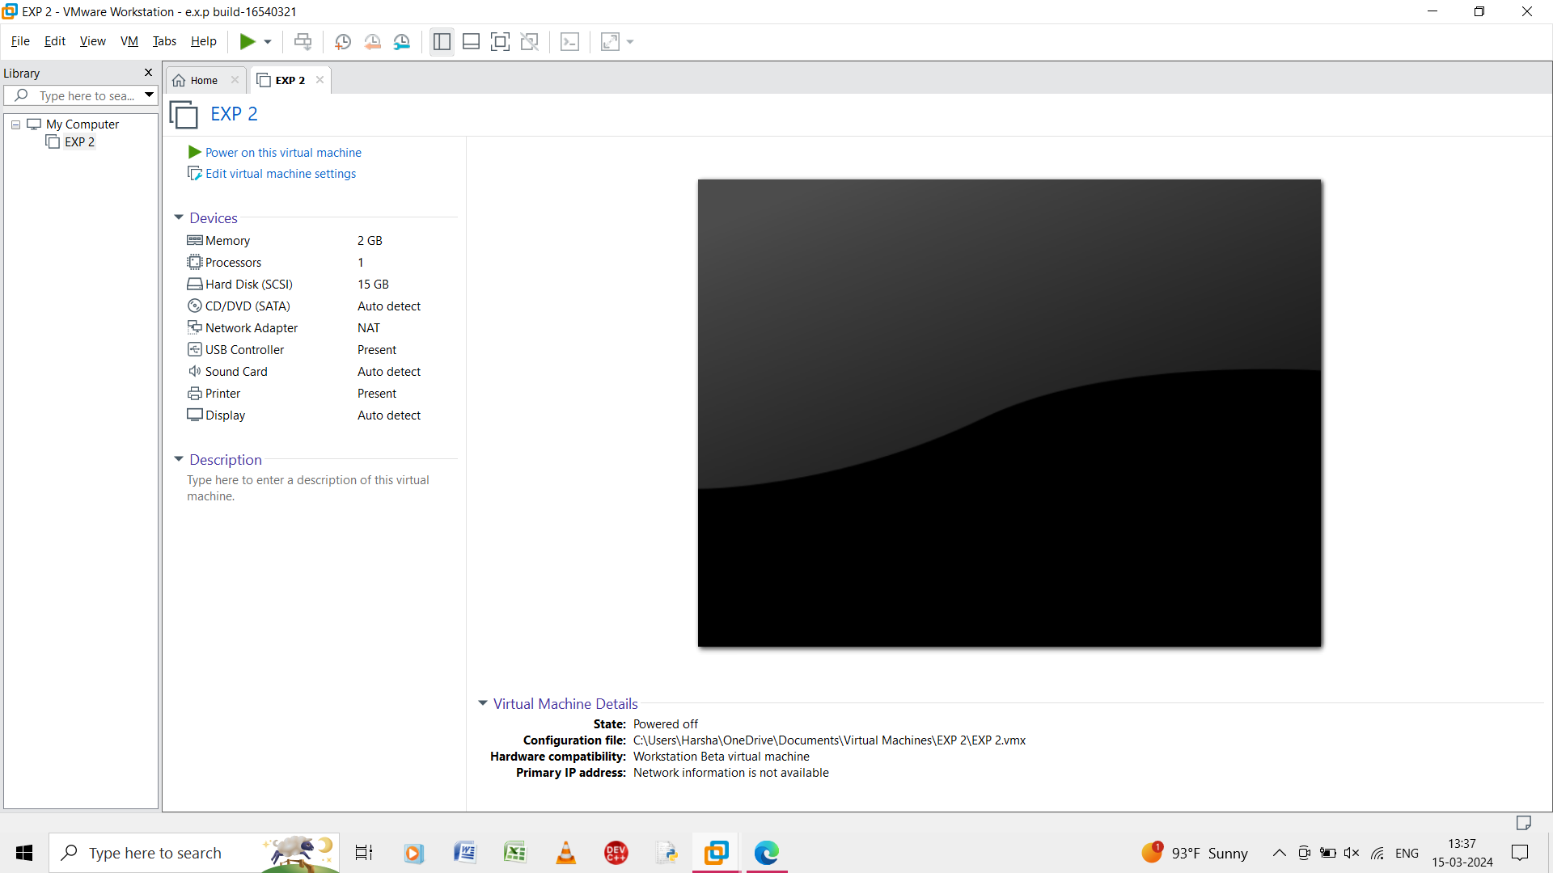

Step 9: the result of the virtual machine is created and shown.